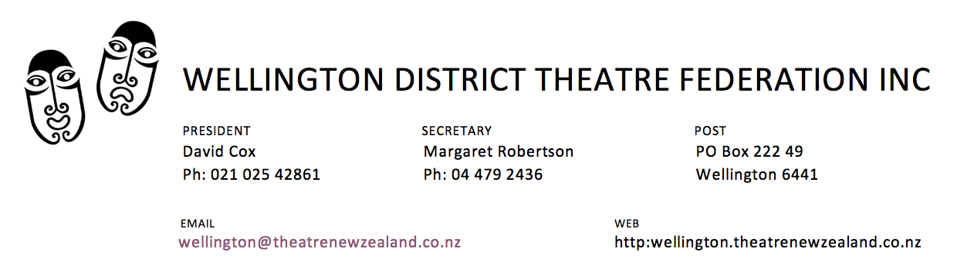

AUGUST NEWSLETTER 2021
Vol 31 Issue 4

DELTA
All our lives are on hold. We feel for those of you who were about to open productions and are now facing uncertainty – can you keep your cast together, will the venue be available at some unknown date, how will you store the set in the meantime etc. Hang in there everyone and stay safe and well.

NEW WEBSITE
Ignore the link on the letterhead – that has to be changed now we have a new website. Have you looked at www.wdtf.org.nz yet? President David is keeping it right up to date and that’s vital in these unsure times.

LOCAL THEATREFEST in Masterton 7 & 8 August
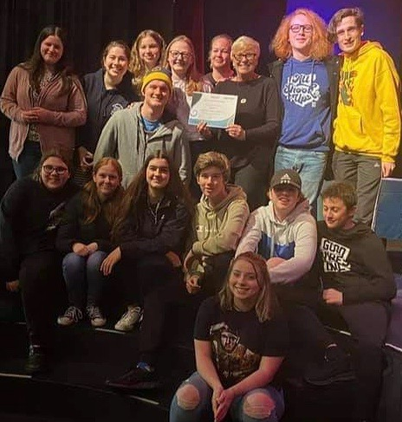
Masterton Theatre Company hosted a most successful festival weekend at the Majestic Theatre. Adjudicator Phil Peleton had 14 entries to assess and the Overall Winner was Chairs by Scott Mullen directed by Linda Voice and Sasha Hart for Masterton Theatre Company. This team also won Best Director(s), Best Technical and Best Youth. Heartiest congratulations to them on all these awards.

Best Adult production was awarded to Khandallah Arts Theatre’s Overtones by Alice Gerstenberg directed by Hayden Rogers. Cast pictured: Annette Cochran, Tanya Piejus, Becky Scoggins, Jessica Hammond
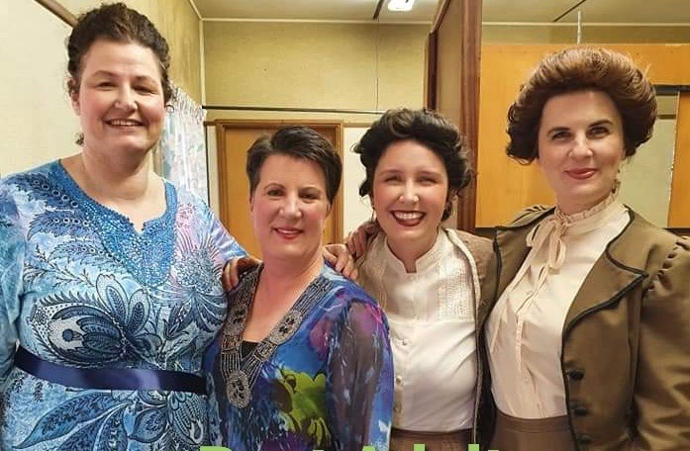

Excellence in Acting Awards were given to Teran Abeydeera (Newlands College), Freya Lewington, Lily Henderson and Matthew Edars (all from Kuranui College) and Becky Scoggins (Khandallah Arts Theatre).
Best New Director was Jasmine Loveday for Maltreatment which she also wrote (Kuranui College)

REGIONAL FINALS
These were due to take place the last two weekends in August but have been cancelled.

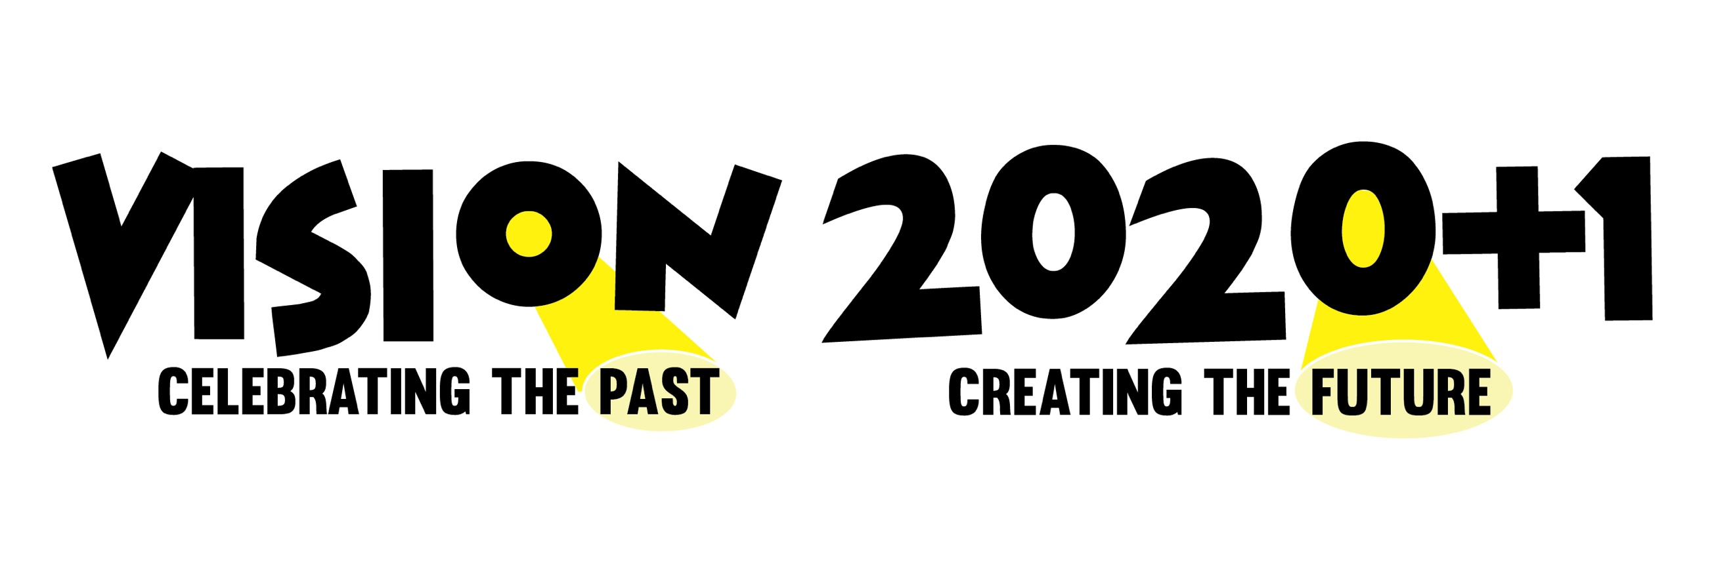
TNZ THEATREFEST NATIONAL FINAL, TNZ’s AGM, National Hui, Workshops and Masterclasses

With much regret the National Executive of Theatre New Zealand has decided not to proceed with the grand weekend planned for 17- 19 September to celebrate our 50th birthday. It was too uncertain that postponing till October would allow the lead in time required for Regionals to take place, depending on the availability of venues, adjudicators and teams as they do.

We thank Ewen Coleman TheatreFest Administrator very much indeed for all the work he did in pulling this year’s festival together and thank the 50+ teams throughout the country for their participation. Regional Finalists will be listed in the next Backchat.

24-HOUR PLAY CHALLENGE at Gryphon Theatre 10 & 11 September
This can only go ahead if we are in Level 1 and given the circumstances this is extremely unlikely on the dates we planned. If possible, however, we will reschedule the 24 Hour Play Challenge for later in October. Keep an eye on the website

FULL LENGTH PLAY FESTIVAL is still going ahead!
Three production were due to be adjudicated in the coming weeks and we sympathise with the groups as they decide what they should do. May they all find a way forward to share their hard work with appreciative audiences when the time is right.

Our Antoinette night of celebration on Sunday 5th December will be going ahead at the Polish Association 257 Riddiford St Newtown. There’s still plenty of time, Delta willing, to enter before the end of November deadline. The entry form is on the website; click on 2021 Festivals and the form is under Downloads.

COMING UP, Delta willing

Kapiti Playhouse Murder by Chocolate by Phil Ormsby September 2 – 22
Stagecraft Theatre Hangman by Michael McDonagh September 29 – October 9
Hutt Repertory Theatre Badjelly the Witch by Alannah O’Sullivan October 4 – 9
Coasters Musical Theatre Mary Poppins from book by PL Travers October 7 – 16
Porirua Little Theatre Peter Pan Jr. from book by JM Barrie October 8 – 16
Wellington Repertory Suddenly Last Summer by Tennessee Williams October 20 -30
WDTF 24 hour Play Challenge TBA

